
VICTORIA JUNIOR COLLEGE

JC2 PRELIMINARY EXAMINATIONS 2024

H1 GEOGRAPHY 8834/01

INSERT 3 hours

READ THESE INSTRUCTIONS

The Insert contains all the Resources referred to in the questions.

This document consists of 9 printed pages
Resource 1 for Question 1

Profile of participants

Number of participants
(Total: 56)
Gender | Women: 53  Men: 3
Marital Status | Married: 41  Single: 3  Widowed: 12
Diagnosed disease | Yes: 44  No: 12
Use assisted aid | Yes: 32  No: 24
Self-rated fitness | Poor: 5  Quite Good: 20  Good: 22  Very Good: 9

Resource 2 for Question 1

Survey Recording Sheet
Gender: Male/Female
Age:
Marital status: Married/Single/Widowed
Diagnosed disease: Yes/No
Use assisted aid: Yes/No

Self-rated fitness (Please tick):
Poor
Quite Good
Good
Very Good

- What is the most important for you to age well? (You can tick ONLY 1 option):
Sense of well-being
Having good physical health
Preserving good mental health

- Who can help you to age well? (You can tick ONLY 1 option):
Family and friends
Medical personnel (e.g. family doctor)
Voluntary Welfare Organisations (e.g. Senior Activity Centres)
Others. Please state below: ______________________________________________________________________________________________________________________________________

- What are some obstacles you faced to age well?
_________________________________________________________________________________________________________________________________________________________________________________________________________

Resource 3 for Question 1

Survey results

Question 1: What is the most important for you to age well?

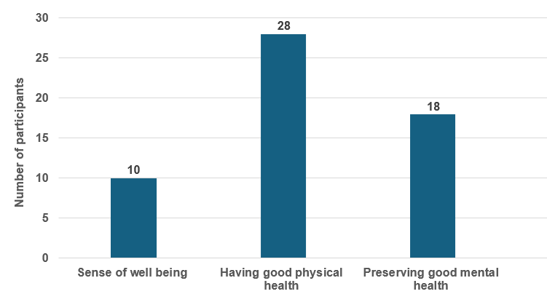

Question 2: Who can help you to age well?

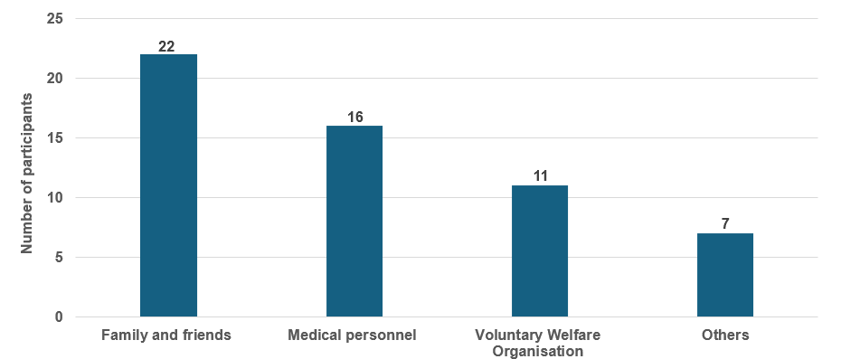

Resource 4 for Question 2

Changes in the Earth Overshoot Day from 1971 to 2024
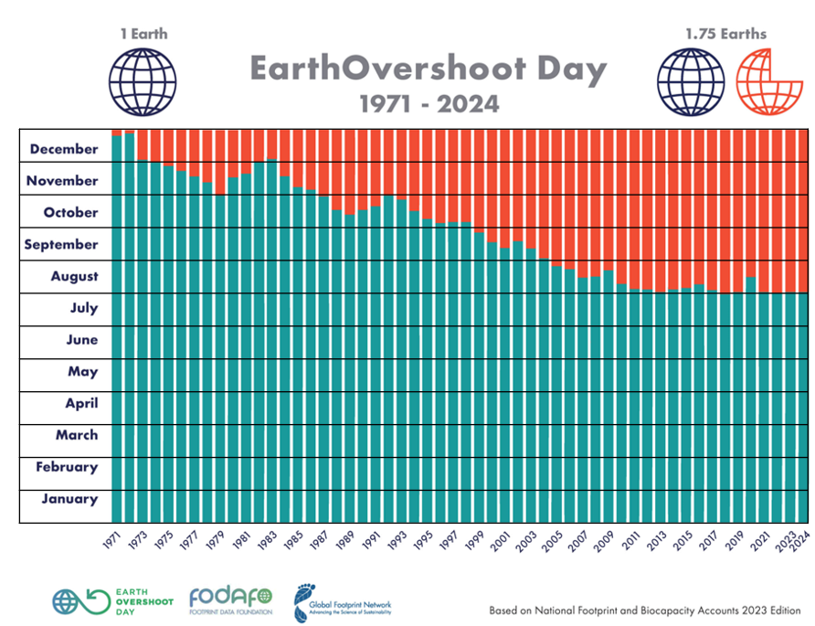
Days living over what earth can regenerate in that year
Days before overshoot is reached

Earth Overshoot Day is the date when humanity’s use of natural resources in that year exceeds what the earth can regenerate in that year. It is computed by dividing the planet’s biocapacity (the amount of ecological resources Earth is able to generate that year), by humanity’s Ecological Footprint, and multiplying by 365, the number of days in a year.

In 1971, the Earth Overshoot Day arrived on 25 December. Yet in 2024, it arrived on 1 August.
Resource 5 for Question 2

Waste disposed by types of settlements in Mthatha, South Africa

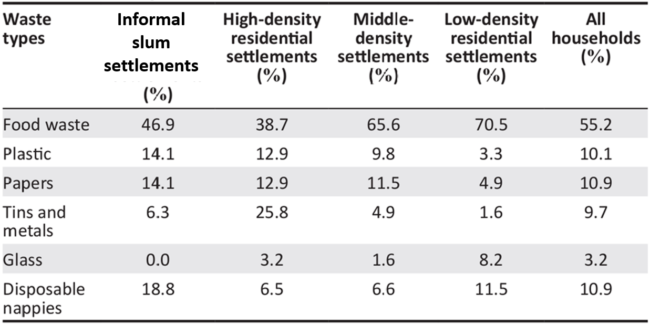
Note: South Africa has a high human development index of 0.71 and 67% of its people live in urban areas. It has the highest Gross Domestic Product amongst African countries.

Resource 6 for Question 2

Locations of different types of settlements in Mthatha

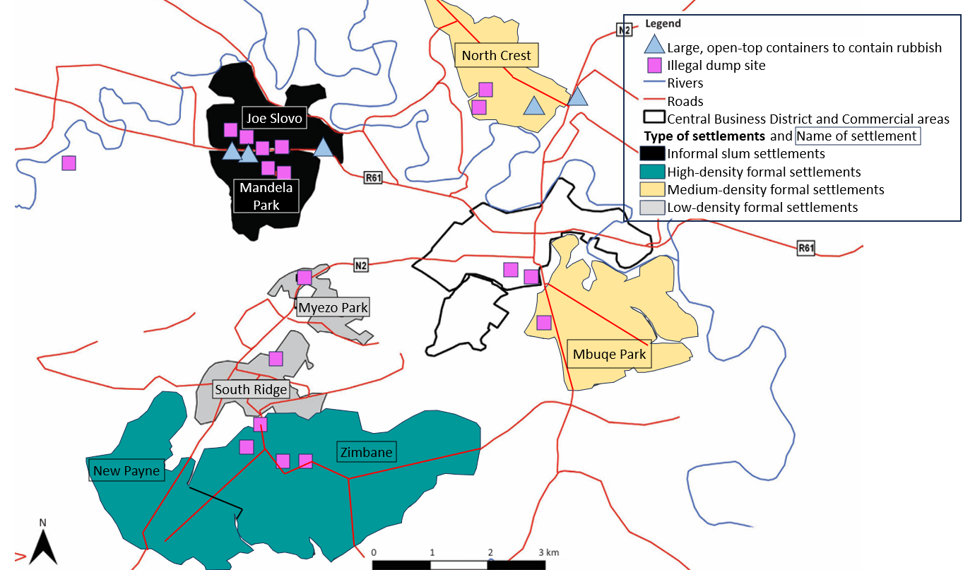

Resource 7 for Question 3

Percentage of carbon dioxide emissions from individual consumption by income groups
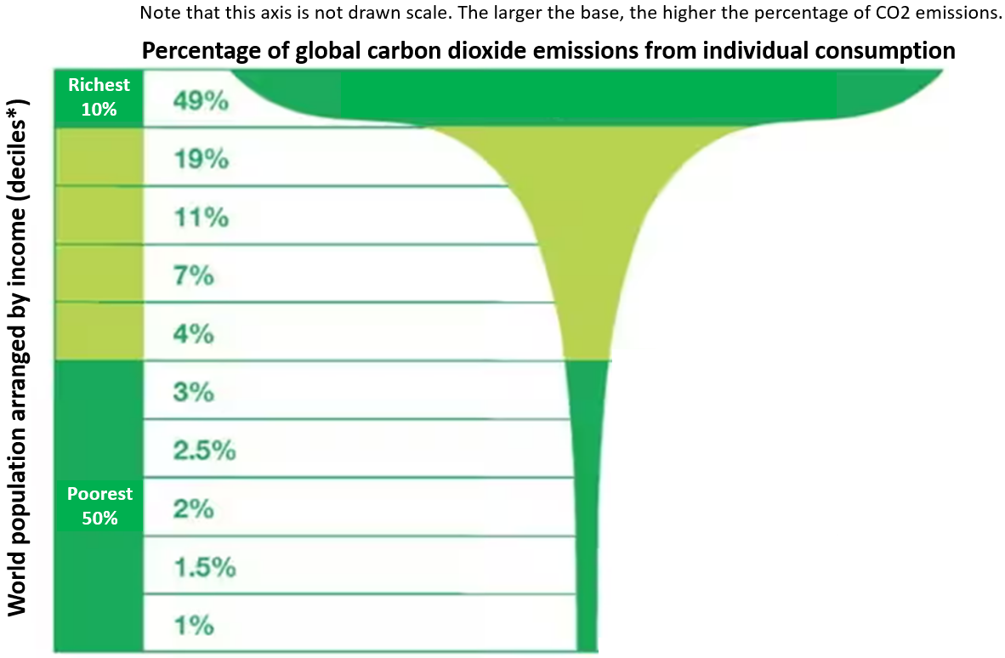
*Decile = 1 decile equates to 10% of the population.

Resource 8 for Question 3

Changes to the global carbon cycle from 2011 to 2020

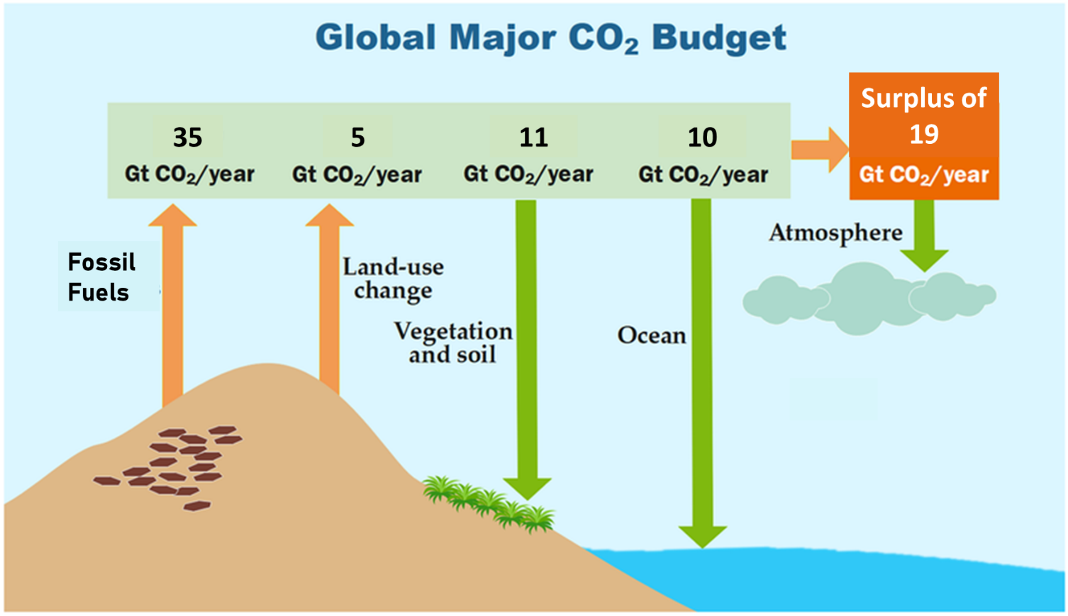
Gt CO₂/ year = gigatonnes of carbon dioxide per year

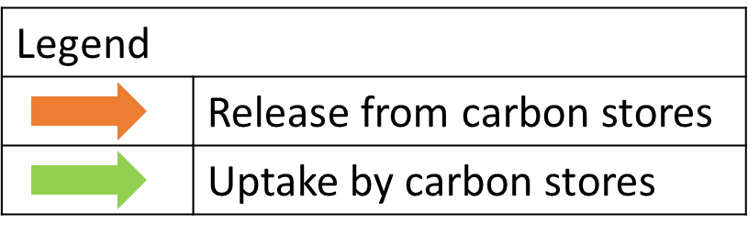

Resource 9 for Question 3

A type of response to climate change

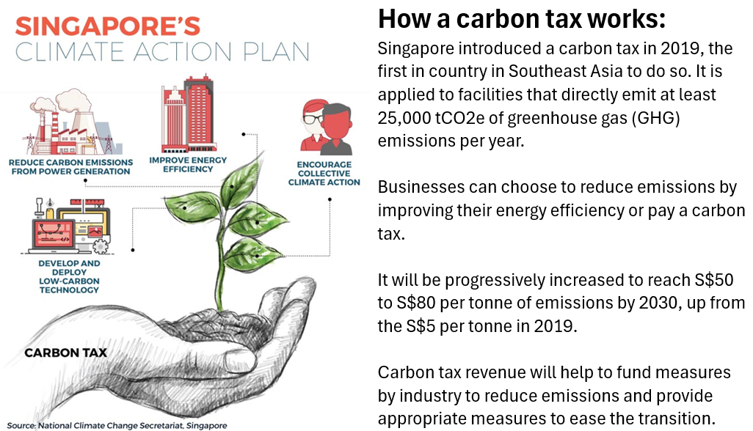

tCO2e = tonnes of carbon dioxide equiavlent

Sources
Resource 1 | Adapted from research: https://onlinelibrary.wiley.com/doi/10.1155/2018/9858252
Resource 2 | Adapted from research: https://onlinelibrary.wiley.com/doi/10.1155/2018/9858252
Resource 3 | Adapted from research: https://onlinelibrary.wiley.com/doi/10.1155/2018/9858252
Resource 4 | https://www.theguardian.com/environment/2015/dec/02/worlds-richest-10-produce-half-of-global-carbon-emissions-says-oxfam
Resource 5 and 6 | https://www.researchgate.net/figure/The-most-common-types-of-waste-according-to-socio-economic-status-Characteristics-of_tbl3_332737149
Resource 7 | https://energyindemand.com/2023/11/25/the-richest-10-are-responsible-for-half-of-all-global-emissions/
Resource 8 | https://www.researchgate.net/figure/The-perturbation-of-the-global-carbon-cycle-for-the-decade-2011-2020-The-CO2-produced_fig1_365799209
Resource 9 | https://theaseanpost.com/article/singapores-carbon-tax-what-does-it-entail

